Test_add_products

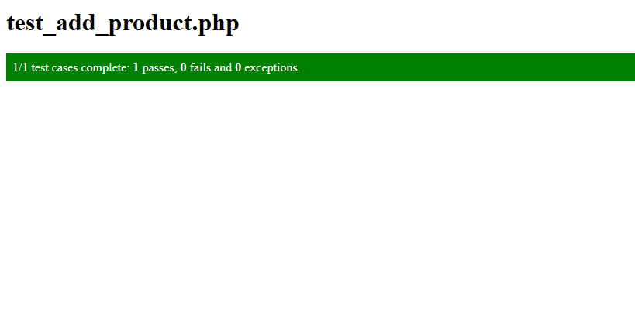The first test that I made is testing add product

To test the function I needed function that look if the product is in the database and other that delete the product

Test_customer_registration

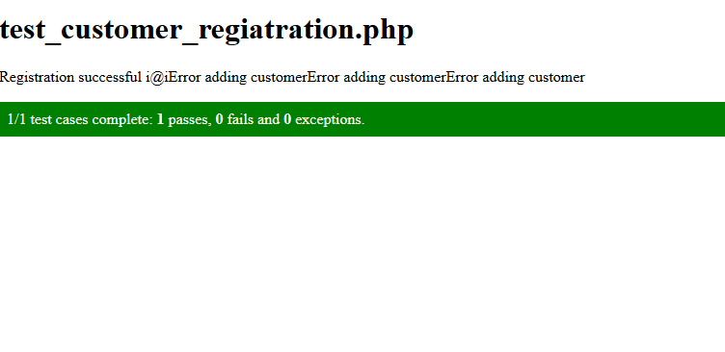the second test is testing customer registration

To test it I need function that look if the customer is in the database then having another function that test if we could delete the product

Test_view_past_order_CMS

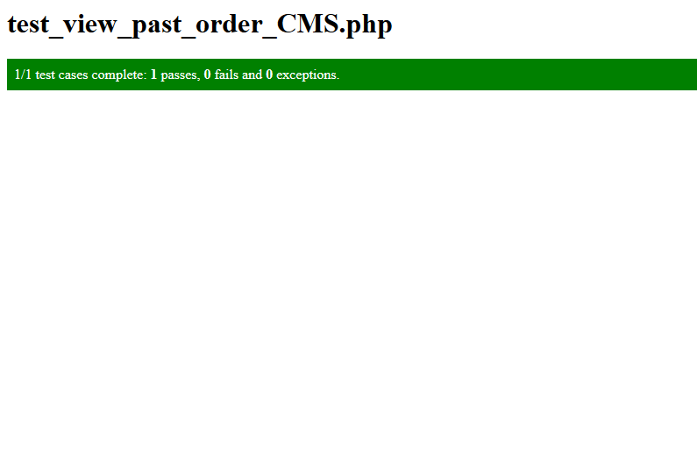

The third test is testing customer order for that I only need to look if the order that the customer made is in the database

Test_edit_products

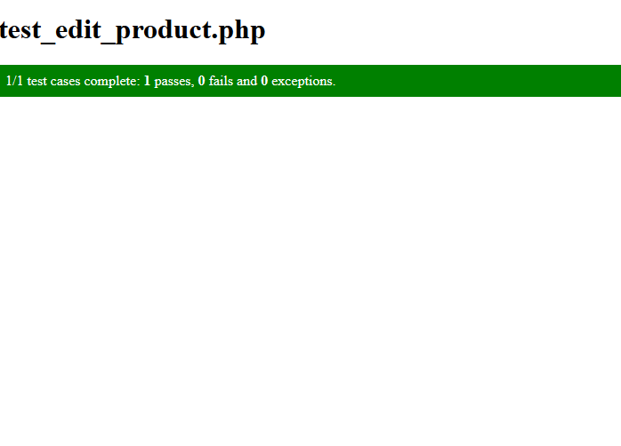

The forth test is testing edit product for that I need a function that look for the product and update it